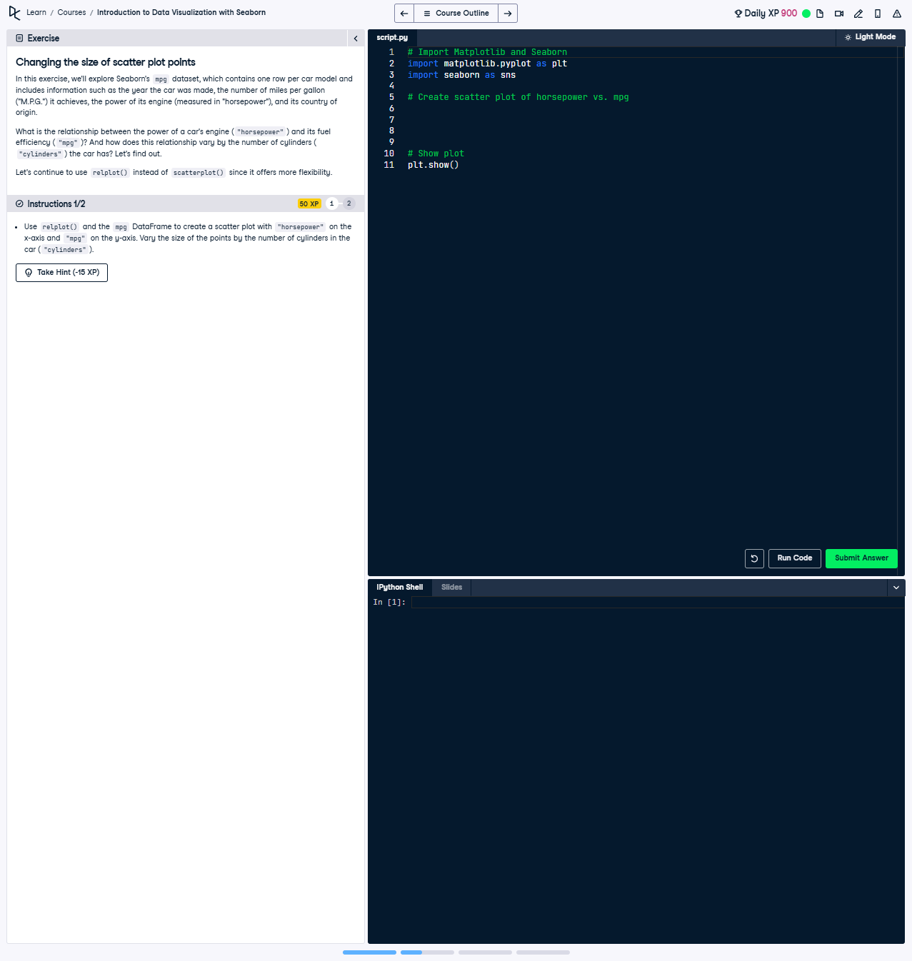

Changing the Size of Scatter Plot Points

Use relplot() and the mpg DataFrame to create a scatter plot with 'horsepower' on the x-axis and 'mpg' on the y-axis. Vary the size of the points by the number of cylinders in the car ('cylinders').

### Full Answer ###

The following code creates a scatter plot using relplot() and varies the size of the points based on the number of cylinders in the car ('cylinders'). Below is the working code:

import seaborn as sns  
import matplotlib.pyplot as plt  
  
# Create scatter plot of horsepower vs. mpg with point size based on cylinders  
sns.relplot(x='horsepower', y='mpg',  
 size='cylinders',  
 data=mpg,  
 kind='scatter',  
 sizes=(10, 200))  
  
# Show plot  
plt.show()

### Code Explanation ###

1. Import seaborn and matplotlib.pyplot for data visualization.  
2. Use sns.relplot() to create a scatter plot with:  
 - 'x' set to 'horsepower' to represent the engine power on the x-axis.  
 - 'y' set to 'mpg' to represent the fuel efficiency on the y-axis.  
 - 'size' set to 'cylinders' to vary the size of the scatter plot points.  
 - 'data' set to mpg, the DataFrame containing the data.  
 - 'kind' set to 'scatter' to generate scatter plots.  
 - 'sizes' set to (10, 200) to control the range of point sizes.  
3. Use plt.show() to render and display the plot.